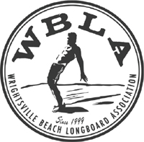

Wrightsville Beach Longboard Association

William Paco Strickland Scholarship

Paco Strickland was a WBLA member, an avid surfer, musician and athlete. The WBLA will award a $500 scholarship in his honor at the September 5, 2016 meeting. This scholarship will be awarded to an active member who exemplifies the characteristics of Paco.

Basic Requirements

High school senior or college student

Current membership in the WBLA
Active participant in one or many of the WBLA committees or events.

Application Requirements

Complete the attached application in its entirety
List any past and current committee or events in which you have been actively involved.

Application Deadline
The application must be turned in by August 31, 2016 to one of the WBLA officers or in the WBLA mailbox on August 31.

WBLA
PO Box 541
Wrightsville Beach, NC 28480

Full Name Date of Birth

Address City/State

Phone Email

College Attending Class Level

WBLA Committees or Events on which you participated

